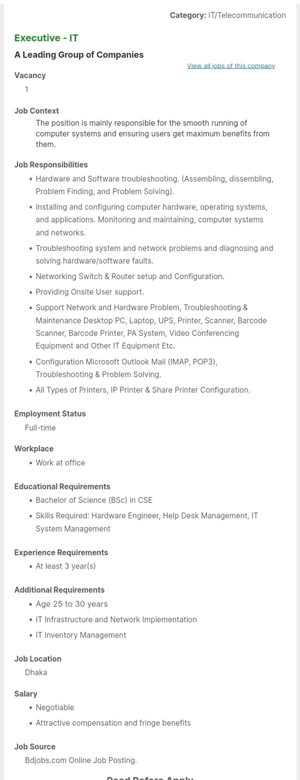
Executive-IT
A Leading Group of Companies.
Dear Concern,
In response to the advertisement published on 14 Oct 2020 on Bdjobs.com, I am writing to express my interest for the position of Executive-IT in your esteemed company, A Leading Group of Companies.
with a good result, I would like to bring my knowledge, skills and commitment to your company’s innovative environment. During my education, I have gained the necessary knowledge that come with the position including Hardware Engineer, Help Desk Management, IT System Management, Advanced Operating System, Network Resource Management, Digital System Design, Simulation & Modeling, Robotics Engineering, Java, Python.
.
My internship at American International University-Bangladesh also afforded me with the crucial skills to work with some of the best professionals in the recruitment and Computer Engineering. During the course of my four months internship, I developed enthusiasm and passion for Software Development and the internship has subsequently convinced me that Computer Engineering is my true calling.

For additional details regarding my qualification and expertise, please review my resume as attached with this letter. I will be reached via email anytime and phone from 9am to 9pm on the weekdays. Thank you for taking the time to consider this application and I look forward to hearing from you at your earliest convenience.

Yours sincerely,
Siam
Nokibul Arfin Siam
01642580210

NOKIBUL ARFIN SIAM
South Jatrabari ♦ Dhaka- 1204
cell: 01575267980 ♦ Email: nokibularfinsiam@gmail.com
CAREER OBJECTIVE
An exciting and challenging job position where there is opportunity to work with people in an environment of excellent and passion and a chance to use and contribute educational experience with ample prospect to develop my career which results in a long-term career growth and perform a creative and exciting job where talents, conceptual ability, Leadership, communication, and innovation can be efficiently utilized.

KEY SKILLS AND COMPETENCIES
- Microprocessor Design | - Java | - Linux
- Operating Systems | - JavaScript | - Hardware
- Debugging | - Python | - HTML

KEY SKILLS AND COMPETENCIES
PROFESSIONAL ABILITIES
- Hardware and Software troubleshooting. (Assembling, dissembling, Problem Finding, and Problem Solving).
- Monitoring and maintaining, computer systems and networks.
- Troubleshooting system and network problems and diagnosing and solving hardware/software faults.
- Maintain LAN/WLAN network
- Excellent leadership skills with the ability to proactively set and maintain priorities.

ACADEMIC QUALIFICATIONS

Bachelor of Computer Science & Engineering (CSE)
Major Subject : Computer Engineering.
Minor Subject : Information Systems.
Institution : American International University – Bangladesh (AIUB).
Result : 3.5 (Out of 4)
Higher Secondary School Certificate (H.S.C.)
Group : Science.
Institution : Dania College.
Board : Dhaka.
Passing Year : 2017
Result : GPA 4.00 (Out of 5)
Secondary School Certificate (S.S.C.)
Group : Science.
Institution : Bausia M.A Azhar High School.
Board : Dhaka.
Passing Year : 2015.
Result : GPA 4.25 (Out of 5)

REFERENCES

Professor of [AIUB]
JANNATUL FARHANA
jannatul@aiub.edu

